**Analysis of Employee Sample Data**

Nadia Al-Salem

14 / 9 / 2025

Table of Contents

Summary: 3

The 3 Main Takeaways 3

What I Recommend to Do Next: 5

# Summary:

This report provides a strategic overview of our current workforce based on an analysis of the provided employee sample data. The objective is to leverage data driven insights to inform key business decisions regarding talent management.

Here’s a quick summary of the three main things I found:

# The 3 Main Takeaways

1. **We have a lot of experienced people.** Most of our employees are between 35 and 55 years old. This is great because it means they have a ton of knowledge, but we need to start thinking about who will fill their shoes when they retire down the road.

This chart shows the age breakdown of our employees. As you can see, the biggest groups are in the 40s and 50s.

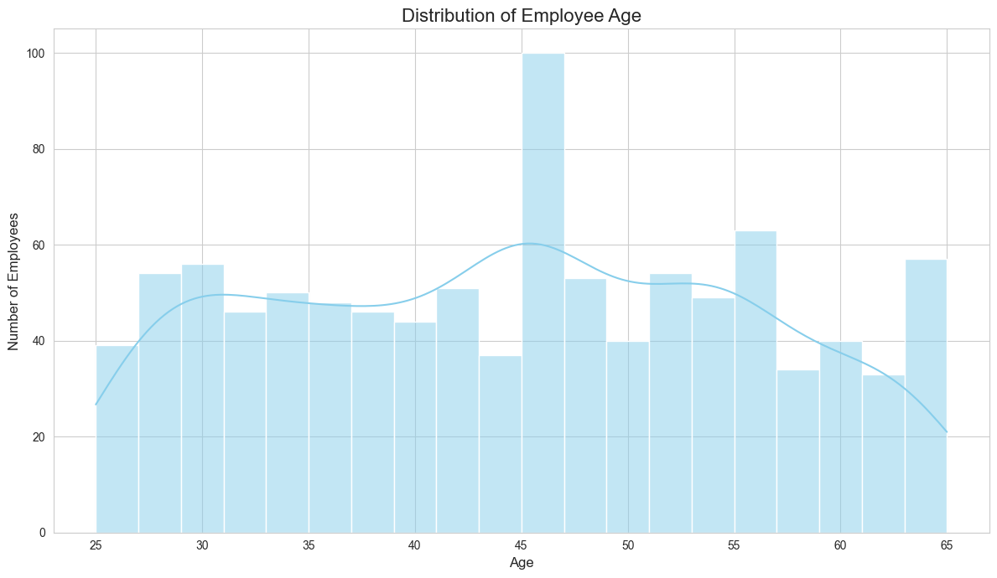

Figure Distribution of Employee Age

1. **Pay differs a lot between departments.** The Marketing department has the highest average salary by a wide margin. This makes me wonder if we're paying competitively in other important areas, which could make it tough to hire and keep good people.

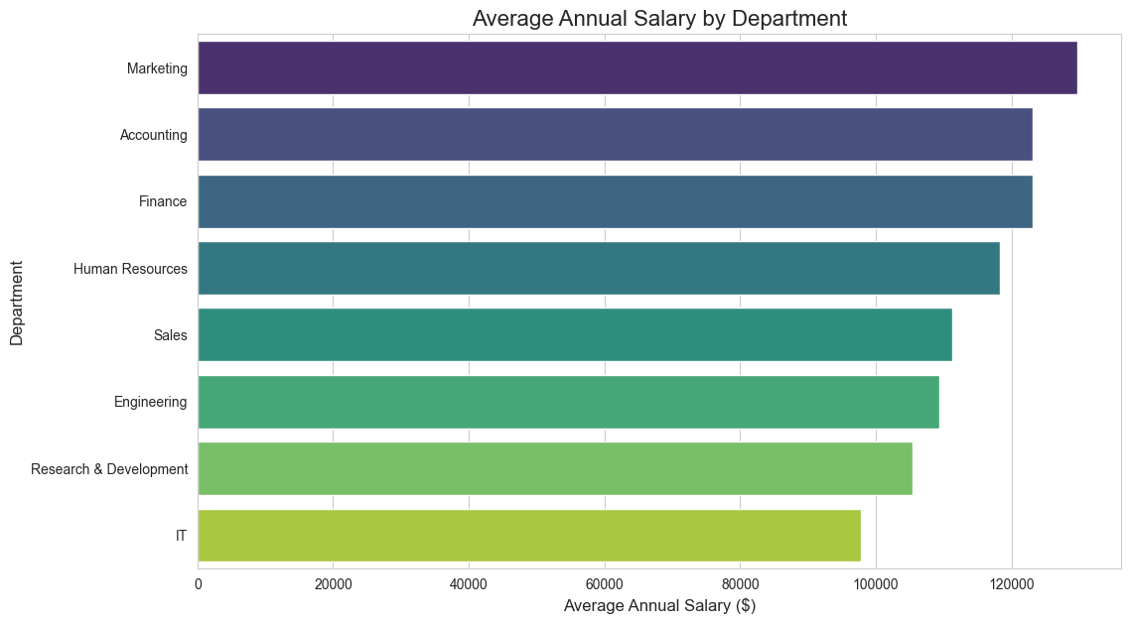

1. **Most of our team is in the US.** Having our staff concentrated in one country helps with teamwork, but it also means we might be missing out on talented people in other parts of the world.

This chart shows that we are heavily based in the United States, with China and Brazil being our next biggest locations.

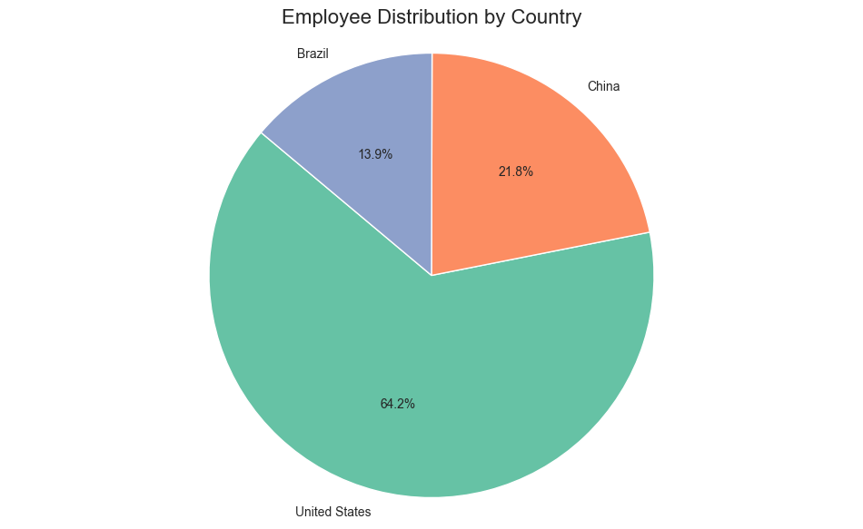

Figure Employee Distribution by Country

# What I Recommend to Do Next:

Based on what I found, here are three things I think we should focus on:

1. **Plan for Retirements:** We should identify the most critical jobs held by senior employees and start a simple mentorship program. This will help pass their knowledge on to the next generation of leaders in the company.
2. **Review the Salaries:** I suggest we take a fresh look at what other companies are paying, especially for roles in departments like IT. Making sure our salaries are competitive will save us a lot of money and headaches in the long run by making it easier to keep our best people.
3. **Hire from More Places:** We could start by creating a clearer remote work policy. This would let us hire talented people who don't live near our main offices and would help diversify our team.